# Design Documentation

# Smart House Project

Revision History

|  |  |  |  |
| --- | --- | --- | --- |
| **Date** | **Version** | **Description** | **Author** |
| 10/09/2015 | 0.1 | Description of device development design. | Jabir Al Fatah, Liaquath Hassan |
| 23/09/2015 | 0.2 | Description of device development design. | Jabir Al Fatah, Paul Damon, Liaquath Hassan |
| 17/10/2015 | 0.3 | Description of device development design. | Jabir Al Fatah |
| 08/11/2015 | 0.4 | Description of device development design. | Jabir Al Fatah |

Design item List

|  |  |
| --- | --- |
| **Requirement Name** | **Priority** |
| D1. Set up connection between microcontroller and device(s) via pins/ports. | Essential |
| D2. Arduino and Processing sketch for communication. | Essential |
| D3. Passing and receiving the information to and from the server through URI. | Essential |

Design Item Descriptions

### D1

Smart house contains devices (both built in and virtual). Our Microcontroller i.e. Arduino will be connected to the devices using Pins/Ports.

### D2

Write Arduino and processing sketch that can communicate with devices. Program will be written such a way that it can exchange data either ways. For example before controlling any device the Arduino has to know the current status of the device. That is, before sending any command to the device; the microcontroller must be aware whether the device is already turned on or off.

**D3**

For server client communication we will use URI to get status from server. In our processing sketch we will write functionality to check the database and update using URI calls.

**UML diagram**

1. **Sequence diagram**

We use sequence diagram to show the actions. The diagrams are given below:

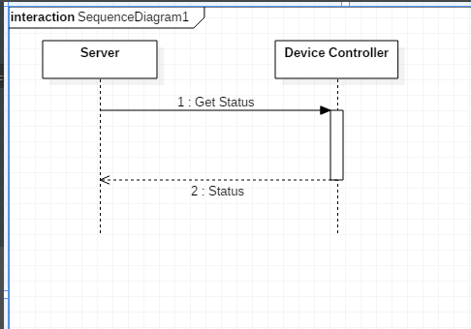

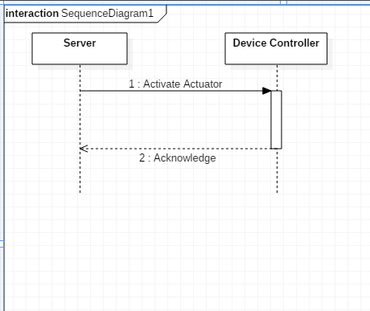

1. **State diagram**

